**Task 1:**

**Problem Statement:**

Writing a logic in main.tf file for creating a azure virtual network with following **parameters name**, **resource group**, **address** and **location** using terrafrom.

**main.tf**

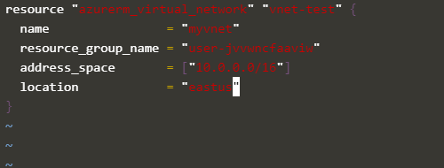

To arrange the format, run the **terraform fmt** command.

Run the **terraform init** command to initialize the terraform environment.

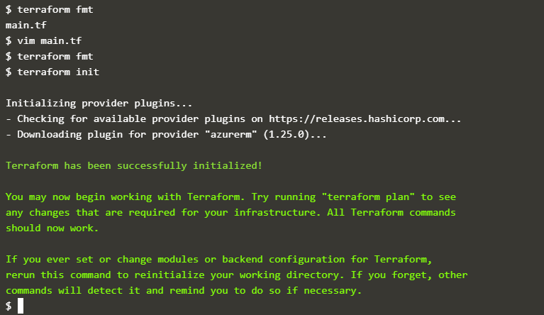

Run the **terraform plan** commands to create the virtual network infrastructure

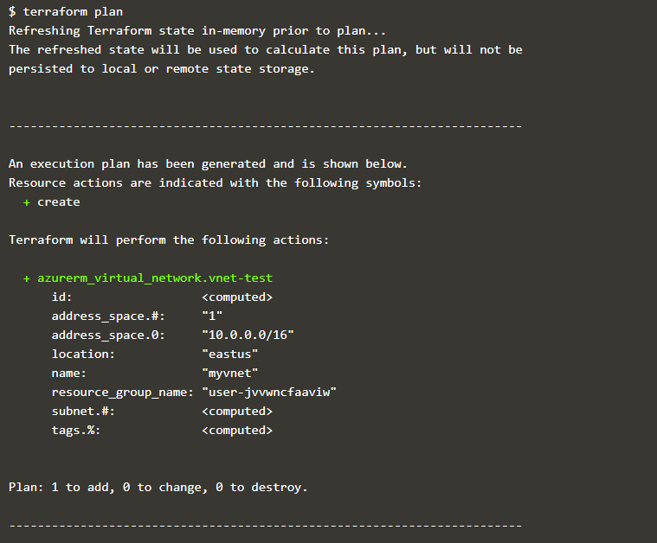

Run the **terraform apply** commands to apply changes to create the virtual network infrastructure.

#### C:\Users\HP\Pictures\Screenshots\Screenshot (321).png

#### Enter “yes” to apply the changes

#### C:\Users\HP\Pictures\Screenshots\Screenshot (323).png

#### Destroying Virtual Network

#### Run terraform destroy command it will destroy the network resource.

#### Enter “yes” to apply the changes to destroy the resource.

